**Concepts and formulas to remember**

**Hydrocarbons**

* Compounds of carbon and hydrogen.
* Classification of Hydrocarbons:   
  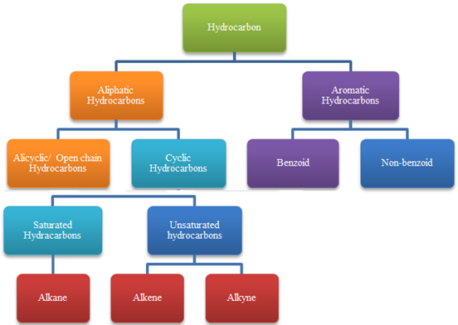

**Alkane**

* Open chain saturated hydrocarbon with general formula (CnH2n+2).
* All the C atoms are single bonded i.e. sp3 hybridised.

**Conformations of Alkane**

* Conformations are the different arrangement of atoms that can be converted into one another by rotation about single bonds.
* Eclipsed Conformation: H atoms on two adjacent carbon atoms are closest to each other i.e. dihedral angle is 0.  
  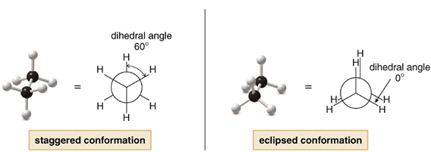
* Staggered Conformation: H atoms on two adjacent carbon atoms are farthest to each other i.e. dihedral angle is 60.

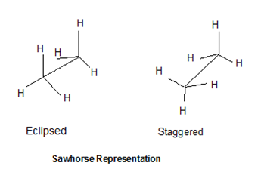       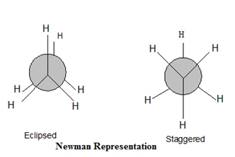

**Preparation of Alkanes:**

* Reduction of Alkyl Halides:

 RX + Zn: + H+  → RH + Zn2+ + X-

4RX + LiAlH4    → 4RH + LiX + AlX3 (X≠ F)

RX + (n - C4H9)3 SnH  → R-H + (n - C4H9)3 SnX

* Grignard Reagent:

**?**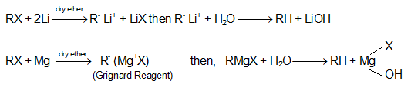

* Hydrogenation of Alkenes:

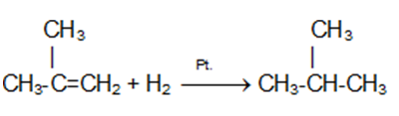

* Wurtz Reaction:

2RX  + 2Na  → R-R + 2NaX

2Na + 2CH3CH2CH2Cl  →  CH3CH2CH2CH2-CH2CH3 + 2NaCl

* Corey House Reaction:



* Decarboxylation of a mixture of the sodium salt of a carboxylic acid:

 RCOONa +NaOH(CaO) → RH +  Na2CO3

* Kolbe's electrolytic method:

2 RCOOK + 2H2O → R-R + 2CO2+ H2+ 2KOH

**Chemical Properties of Alkane**

* Direct Halogenation

RH + X2→ RX + HX

Order of Reactivity of X2:    F2 > Cl2 > Br2; I2 does not react

?a. Initiation Step

Cl-Cl \overset{uv}{\rightarrow}2Cl.

b. Propagation Step

H3C-H +Cl**.** → H3C**.** + H-Cl

H3C**.** + Cl-Cl → H3C-Cl +Cl**.**

c. Termination Step

Cl**.** + Cl**.** →Cl-Cl

H3C**.** + H3C**.**→ H3C-CH3

Cl**.** + H3C**.** → Cl-CH3

* Nitration

Nitration of alkane is made by heating vapours of alkanes and HNO3 at about 400oC to give nitroalkanes.

¨This is also known as vapour phase nitration.



* Combustion:

**?**Alkanes burn readily with non luminous flame in presence of air or oxygen to give CO2 & water along with evolution of heat.

C2H6+ 7O2 → CO2 +6H2O + heat

* Aromatization

**?**¨Alkanes having six to 10 carbon atoms are converted into benzene and its homologues at high pressure and temperature in presence of catalyst.



* Oxidization of 30alkane:?

Tertiary alkanes are oxidized to tertiary alcoholsby KMnO4

 R3CH + KMnO4 → R3COH

**Alkene (olefins)**

* Open chain, Unsaturated hydrocarbons with general formula (CnH2n).
* At least one  >c=c<  (double bond) group i.e. sp2 hybridisation, is present throughout the chain.
* Allene: alkene molecule in which at least one C has double bonds with each of the adjacent carbon i.e. -c=c=c- group.
* Isomeric with saturated cycloalkanes.

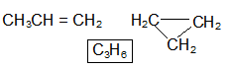

**Geometric Isomers:**

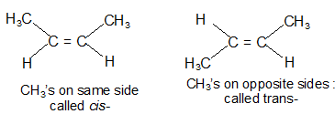

Z is used if the higher - priority substituents on each C are on the same side of the double bond.letter E is used if they are on opposite sides

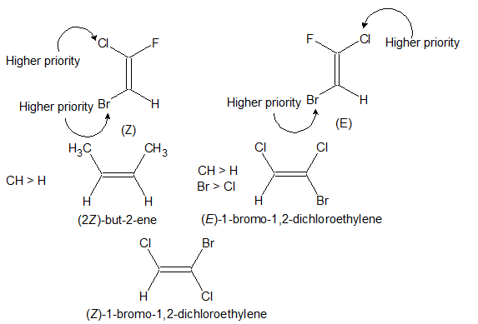

Heats of Hydrogenation: Heat of hydrogenation increases with increase in stability of alkene.

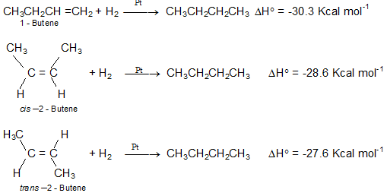

**Order of heat of hydrogenation:** 1-Butene> cis-2-Butene > trans-2-Butene

**Order of stability:** 1-Butene> cis-2-Butene > trans-2-Butene

**Preparation of Alkenes:**

1. Cracking of petroleum:  

2. Dehydrohalogenation of alkyl halides:RCH2CH2X + alc.KOH → RCH = CH2

3. Dehydration of Alcohols :

Saytzeff Rule: In dehydration and dehydrohalogenation the preferential order for removal ofan H is 3° > 2° > 1°

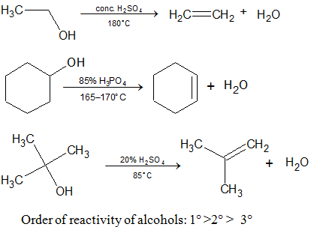

4. Reduction of alkynes:

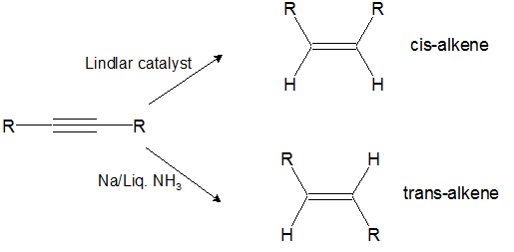

**Chemical Properties:**

1. Electrophilic Polar Addition Reactions

|  |  |  |  |
| --- | --- | --- | --- |
| **Reagent** | | **Product** | |
| **Name** | **Structure** | **Name** | **Structure** |
| Halogens  (Cl2, Br2 only) | X:X | Ethylene dihalide | CH2XCH2X |
| Hydrohalic acids | H:X | Ethyl halide | CH3CH2X |
| Hypohalous acids | X:OH | Ethylene halohydrin | CH2XCH2OH |
| Sulfuric acid (cold) | H:OSO2OH | Ethyl bisulfate | CH3CH2OSO3H |
| Water (dil. H3O+) | H:OH | Ethyl alcohol | CH3CH2OH |
| Borane | H2B:H | Ethyl borane | (CH3CH2BH2) → (CH3CH2)3B |
| Peroxyformic acid | H:O-OCH=O  (HCO3H) | Ethylene glycol | CH2OHCH2OH |

2. Addition of Hydrogen Halides to Alkenes: Markovnikov’s Addition:

R - CH= CH2+ HBr → R – CHBr – CH3

**Mechanism:**

R - CH= CH2+ HBr → R – CH+- CH3 +Br-  
R – CH+- CH3+ Br-→ R – CHBr- CH3

Anit- Markovnikov’s Addition (Peroxide Effect):

R - CH= CH2+ HBr + (C6H5CO)2O2 → R – CHBr – CH3

**Mechanism**

Initiation:

R - O - O - R  →  2RO**.**

RO**.** +  HBr  →  Br**.**   +   ROH

Propagation

CH3CH = CH2   + Br**.** →   CH3·CH - CH2Br

CH3·CHCH2Br + HBr→ CH3CH2CH2Br + Br**.**

Termination:

2RO**.**  →  R - O - O - R

Br**.**+ Br**.**→Br2

3. Addition of Water to Alkenes: Acid Catalyzed Hydration:

|  |  |  |  |
| --- | --- | --- | --- |
| **Reagent** | | **Product** | |
| **Name** | **Structure** | **Name** | **Structure** |
| **Halogens**  **(Cl2, Br2 only)** | X:X | Ethylene dihalide | CH2XCH2X |
| **Hydrohalic acids** | H:X | Ethyl halide | CH3CH2X |
| **Hypohalous acids** | X:OH | Ethylene halohydrin | CH2XCH2OH |
| **Sulfuric acid (cold)** | H:OSO2OH | Ethyl bisulfate | CH3CH2OSO3H |
| **Water (dil. H3O+)** | H:OH | Ethyl alcohol | CH3CH2OH |
| **Borane** | H2B:H | Ethyl borane | (CH3CH2BH2)®(CH3CH2)3B |
| **Peroxyformic acid** | H:O - OCH = O  (HCO3H) | Ethylene glycol | CH2OHCH2OH |

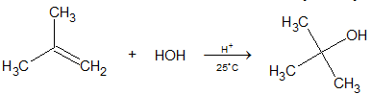

4. Oxymercuration-Demercuration:

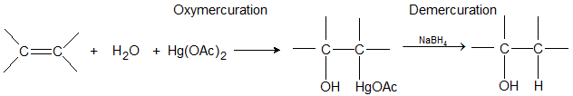   

**Examples:**

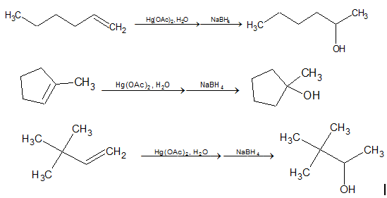

5. Hydroboration-Oxidation:

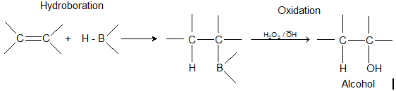

**Examples:**  
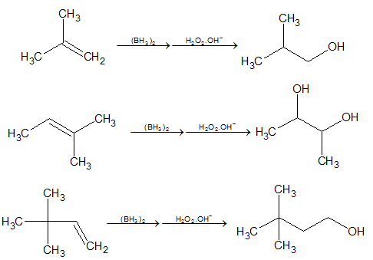

6. Halogen Addition in Non-polar Solvent: 

7. Halogen Addition in Aqueous Medium:  
  
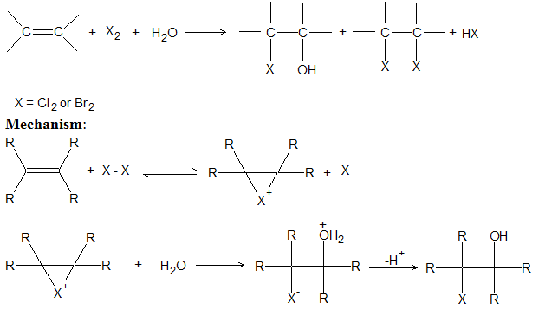

8. Syn – Hydroxylation: Formation of di-oles.   
               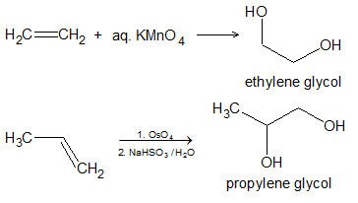

9. Ozonolysis of Alkenes:

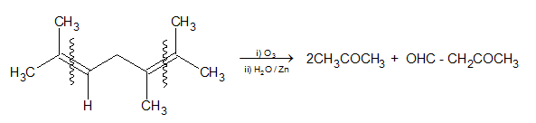

**Alkyne**

* Saturated open chain hydrocarbon with general formula (CnH2n-2).
* At least one -c≡c-  (triple bond) group i.e. sphybridisation, is present throughout the chain.
* Physical properties of alkynes are similar to those of the corresponding  alkenes

**Preparation**

1. Dehydrohalogenation of vic-Dihalides or gem-Dihalides

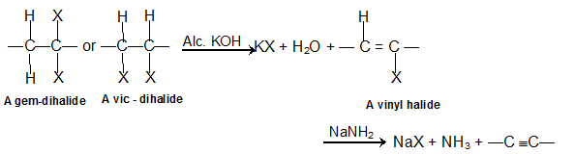

2. Dehalogenation of vic-Tetrahalogen Compounds  
  


3. Alkyl Substitution in Acetylene; Acidity of º C-H



4. From Calcium Carbide:

**CaC2 +2H2O →   Ca(OH)2+ C2H2**

5. Kolbe’s Electrolysis:

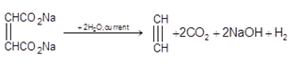

**Chemical Properties**

**1. Hydrogenation: RC ≡ CCH2CH3 + 2H2 →  CH3CH2CH2CH2CH3**

**2. Hydro-halogenation:**

**Markovnikov addition:**RC≡CH +HBr → RCBr=CH2 +HBr→ RCBr2-CH3

**Anti-markovnikov addition: RC≡CH +HBr +peroxide → RCH=CHBr**

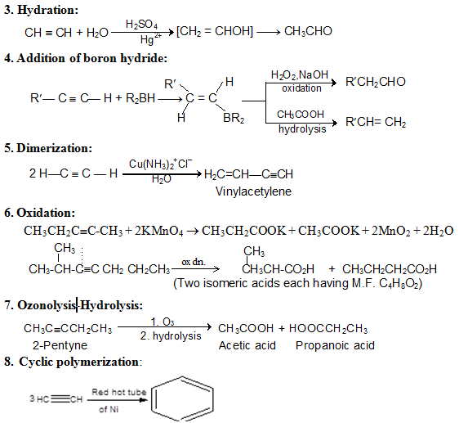

**Aromatic Hydrocarbons:**

**For being aromatic a hydrocarbon should**

* be a cyclic compounds.
* have planarity in geometry.
* have complete delocalization of electrons over ring.
* follow Huckel Rule i.e. number of ?? electrons in ring = (4n+2).                         :

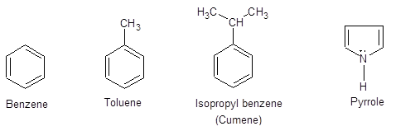

**Benzene (C6H6)**

1. Structure:

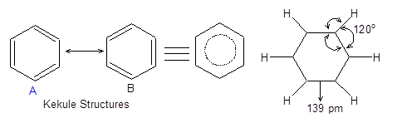

 2. Chemical Reactions of Benzene:

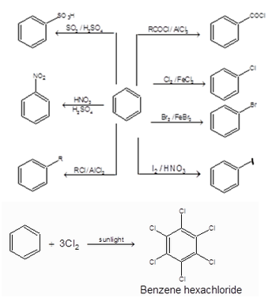

**Anti-aromatic Hydrocarbons:**

Highly unstable compounds.

Number of π electrons in ring = 4n.

Example:

Anti-aromatic Hydrocarbons